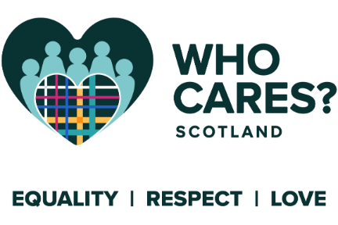

CONFIDENTIAL
Who Cares? Scotland
Equality Monitoring Form

We recognise that the diversity of everyone who works at Who Cares? Scotland enriches the work experience for all. No applicant will be treated less favorably on the grounds of care background, social background, age, disability, gender, gender reassignment, race, religion or belief, sexual orientation, marital or civil partnership or pregnancy/maternity.
The information that you provide enables us to monitor the diversity profile of our job applicants and our workforce. We ask that you complete this form and return it with your application form. The information you provide will not be used for selection purposes and used for monitoring purposes only.
Please choose an option from each of the sections below and cross (X) the appropriate box. Thank you for your assistance.
- Are you Care Experienced? i.e. did you grow up, or have you ever been in, foster care, residential care, kinship care or been looked after at home?
Yes
No
Prefer not to say
If yes, please describe if you feel comfortable doing so
- Which of the following best describes your gender?
Female
Male
Non-binary
Prefer not to say
Other: please describe if you feel comfortable doing so

- Gender identity
DO YOU IDENTIFY AS TRANS
Yes
No
Prefer not to say

- Age
What is your age?
16-24 ∗ 25-29 ∗ 30-34 ∗ 35-39 ∗ 40-44 ∗ 45-49 ∗
50-54 ∗ 55-59 ∗ 60-64 ∗ 65+ ∗ Prefer not to say ∗
- How do you describe your ethnicity?
WHITE
Scottish
English
Irish
Northern Irish
Welsh
British
Polish
Other: please describe
MIXED OR MULTIPLE ETHNIC GROUPS:
Please describe if you feel comfortable doing so
ASIAN, ASIAN SCOTTISH OR ASIAN BRITISH:
Bangladeshi, Bangladeshi Scottish or Bangladeshi British
Chinese, Chinese Scottish or Chinese British
Indian, Indian Scottish or Indian British
Pakistani, Pakistani Scottish or Pakistani British
Other: please describe if you feel comfortable doing so
BLACK, BLACK SCOTTISH OR BLACK BRITISH:
African, African Scottish, African British
Black, Black Scottish, Black British
Caribbean, Caribbean Scottish, Caribbean British
Other: please describe if you feel comfortable doing so
OTHER ETHNIC GROUP:
Please describe
- Do you consider yourself to have a disability?
Yes
No
Prefer not to say
IF YES, PLEASE PROVIDE FURTHER DETAILS IF YOU FEEL COMFORTABLE DOING SO
Deafness or partial hearing loss
Blindness or partial sight loss
Learning disability (e.g. Down’s Syndrome)
Learning difficulty (e.g. Dyslexia)
Developmental disorder (e.g. Autistic Spectrum Disorder or Asperger’s Syndrome)
Physical Disability
Debilitating mental health condition
Long-term illness, disease or condition
Other: please describe
- How do you describe your sexuality?
Heterosexual (Straight)
Gay
Lesbian
Bisexual
Other: please describe if you feel comfortable doing so
Prefer not to say
- What is your marital status?
Married
Civil Partnership
Single
Widowed
Other: please describe if you feel comfortable doing so
Prefer not to say
- How do you describe your religion or belief?
Church of Scotland
Roman Catholic
Christian (other)
Buddhist
Hindu
Jewish
Muslim
Pagan
Sikh
Another religion or belief (please describe)
Prefer not to say
- What is your pregnancy/maternity status?
Are you pregnant or have you had a baby in the last 12 months?
Yes
No
Prefer not to say
NOT APPLICABLE
- Do you speak English as a first language?
Yes
No
If no, please detail your first language(s):

