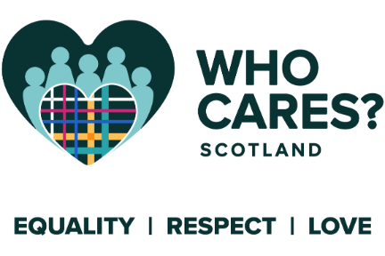

CONFIDENTIAL
Who Cares? Scotland
Equality Monitoring Form

We recognise that the diversity of everyone who works at Who Cares? Scotland enriches the work experience for all. No applicant will be treated more or less favourably on the grounds of their care background, age, disability, gender, gender reassignment status, race, religion or belief, sexual orientation, marital or civil partnership status or pregnancy/maternity status.
The information that you provide will help us to monitor the diversity profile of our workforce and the effectiveness of our equalities policy. We ask that you complete this form and return it with your application form. The information you provide will be treated as confidential, kept separate from your application form, will not be used for selection purposes and used for monitoring purposes only.
Please choose an option from each of the sections below and cross (X) the appropriate box. Thank you for your assistance.
- Do you have a background of Care Experience? i.e. did you grow up, or have you ever been in, foster care, residential care, kinship care or been looked after at home?
Yes
No
Prefer not to say
If yes, please describe if you feel comfortable doing so
- How do you describe your gender?
Female
Male
Non-binary
Prefer not to say
Other: please describe if you feel comfortable doing so

- What is your date of birth?
Date of Birth
Prefer not to say
- Gender reassignment
DOES YOUR GENDER DIFFER FROM THE SEX YOU WERE ASSIGNED AT BIRTH
Yes
No
Prefer not to say
- Do you consider yourself to have a disability?
Yes
No
Prefer not to say
IF YES, PLEASE PROVIDE FURTHER DETAILS IF YOU FEEL COMFORTABLE DOING SO
Deafness or partial hearing loss
Blindness or partial sight loss
Learning disability (e.g. Down’s Syndrome)
Learning difficulty (e.g. Dyslexia)
Developmental disorder (e.g. Autistic Spectrum Disorder or Asperger’s Syndrome)
Physical Disability
Debilitating mental health condition
Long-term illness, disease or condition
Other: please describe
- How do you describe your ethnicity?
WHITE
Scottish
English
Irish
Northern Irish
Welsh
British
Polish
Other: please describe
MIXED OR MULTIPLE ETHNIC GROUPS:
Please describe if you feel comfortable doing so
ASIAN, ASIAN SCOTTISH OR ASIAN BRITISH:
Bangladeshi, Bangladeshi Scottish or Bangladeshi British
Chinese, Chinese Scottish or Chinese British
Indian, Indian Scottish or Indian British
Pakistani, Pakistani Scottish or Pakistani British
Other: please describe if you feel comfortable doing so
BLACK, BLACK SCOTTISH OR BLACK BRITISH:
African, African Scottish, African British
Black, Black Scottish, Black British
Caribbean, Caribbean Scottish, Caribbean British
Other: please describe if you feel comfortable doing so
OTHER ETHNIC GROUP:
Please describe
- How do you describe your religion or belief?
Church of Scotland
Roman Catholic
Christian (other)
Buddhist
Hindu
Jewish
Muslim
Pagan
Sikh
Another religion or belief (please describe)
Prefer not to say
- What is your marital status?
Single
Co-habiting
Married or in a civil partnership
Widowed
Other: please describe if you feel comfortable doing so
Prefer not to say
- How do you describe your sexuality?
Heterosexual (Straight)
Asexual
Bisexual
Gay
Lesbian
Other: please describe if you feel comfortable doing so
Prefer not to say
- What is your pregnancy/maternity status?
Are you pregnant or have you had a baby in the last 12 months?
Yes
No
Prefer not to say
NOT APPLICABLE
- Do you speak English as a first language?
Yes
No
If no, please detail your first language(s):

